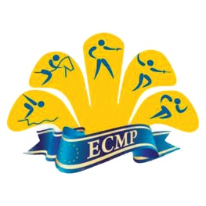
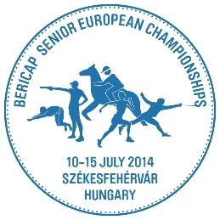
2014 Bericap Senior European Championships
Székesfehérvár, Hungary
09 April – 15 May 2014

Press Accreditation Form

Return no later than 24th June

Surname: _______________ First Name: _________________ Date of Birth: _______

AIPS Card Number: ___________ Name of Company:________________________

Address: ___________________________________________________________

Tel number: __________ Fax number:___________ E Mail: __________________

Type of Media Represented: (please mark with x)

Written/Photo Press:

International Agency Daily Newspaper Freelance

National Agency Magazine Others

Photo Agency Photographer

Electronic Media:

TV Commentator, Director Radio Commentator, Director

TV Staff/Technician Radio Staff/Technician

Special requirements:

Dress Code: long pants and shirt!
You will receive an accreditation card and press vest exchange for deposit fee
The completed form, please send to hmpa@pentathlon.hu

*Registered media will be notified of Media Operations options and rates at a later date

